Phenomenal Mathematics  
as a source of pedagogic strategies   
for learning from e-screens

John Mason  
EARCOME6:   
Innovations and Exemplary Practices in Mathematics Education  
March 2013

## Introduction

Electronic screens (e-screens for short) are quickly becoming the core medium for accessing mathematics (or at least discussing) and much else besides! My concern here is with the need for innovative practices that encourage and enable people to learn from their experience of material on e-screens. As I pointed out more than 25 years ago (Mason 1985) the real question when working with electronic media of various kinds is ‘what happens when you turn off the machine?’. There is a moment of blankness, of transition between worlds when the machine is ‘turned off’. It is in that moment, that gap, that it is possible to make effective use of the experience. Once the new world is entered, there remain only fragmentary residues of the old.

The question arose for me from experience with mathematical films and posters in face-to-face settings, and with the use of audio-recordings to provide a ‘tutor in the head’ for students while studying mathematics at a distance through the Open University. The question is even more pressing with current e-screens (laptops, tablets, smart phones, and smart boards), since it is amplified and complexified by the ‘click and go’ mentality that these hand-held devices support and promote[1]. In order to prompt learners to get something useful from phenomena in the virtual world of e-screens, I suggest that it is vital to develop practices particularly suitable for work with e-screens, so that learners become aware of actions that they can initiate themselves in order to learn effectively from interacting with e-screen material. Similar practices apply to phenomena in the material world, so e-practices may not differ from classroom and home study practices, but with the spread of e-screens it may be even more important than before to enculturate learners into suitable practices for learning mathematics effectively.

## Central Issue

Having watched something happen on a screen, what further actions are required in order to learn effectively from the experience? As I have observed many times (Mason 1998; Mason & Johnston-Wilder 2004a p263),

One thing we do not seem to learn from experience …

… is that we do not often learn from experience alone.

Something more is usually required. Just because I have watched an animation, played a game, or seen a short video, it does not follow that anything essential has changed, nor that anything has been learned. Change of medium is much like swiping a smart screen: what was present, vanishes; what displaces it attracts full attention. Everything changes and what was present before is now absent. This phenomenon also applies to reading a book: when you close the book there is often a moment of being between worlds, the world of the book and the material world of sensations, or perhaps a fresh world of cognition. Sometimes there is even a period of overlap, where emotions from one world overlap and even overlay emotions in response to the material world. The same can happen when watching films, animations, attending lectures, and particularly, puzzling about things happening on screens. The problem with e-screens is that the transition is much more rapid than with a physical book.

The intensity of experience that gives rise to this phenomenon is diminished and watered down by the smart-screen tendency to ‘click and go’ using available buttons, reducing the impetus to stay on one thing in order to try to puzzle it out. The origins of the expression ‘five-minute culture’ are obscure, but it has become a label for essentially the same phenomenon: as soon as immediate stimulation begins to decay, there is a growing tendency to ‘click and go’, meaning that anything that does not sustain attention lasts for around 5 minutes at best. There is an attention threshold that is person and screen dependent, and beyond which attention wanders to seek another boost of stimulation. There are even parallels with addiction. There are also practices which play on this notion: twitter and its 140 character restriction, and ‘five minute talks’ have become widespread in dating, marketing and even some academic situations.

If exposure to something brief acts as a stimulus for further contemplation and study, then it may serve a useful purpose as a taster, but there is considerable danger if it is assumed or considered to be contact in depth. The following tasks may provide some immediate experience of these phenomena, and of some practices that can counteract the ‘click and go’ tendency.

## Some Mathematical Stimuli

One of my conjectures is that every mathematical topic in school and through most of university studies can be introduced by exposure to some phenomenon which that topic helps to explain. Variations on that phenomenon can also be used effectively for revision and for assessment. In the remainder of this paper I offer some examples of e-screen introductions of phenomena that can be explained using mathematical thinking from the curriculum, and so used as introduction, revision or assessment of student comprehension of the topic. I have selected representative tasks from primary, lower secondary, upper secondary and tertiary to illustrate my conjecture and to act as case studies concerning practices which could become effective as e-practices. In the final section I consider obstacles to instituting practices in an e-environment.

### Patterns From 2

This family of tasks is aimed at students who need to practice working with fractions while at the same time working on expressing generality through seeking to express structural relationships.

The applet (Mason 2013a) generates expressions bit by bit: thus

2 2 + 2 2 + 2 = 2 + 2 = 2 x 2

Presented by a teacher in plenary, the steps can be used to provoke learners to anticipate what might be coming and so to experience some surprise and intrigue when their expectations are challenged (for example, most people expect 4 to appear on the right hand side of the equality).

The applet goes on to generate a sequence of expressions using a common structural relationship:

2 + 2 = 2 x 2



Most people quickly see patterns between the expressions, using what Watson (2000) calls *going with the grain*. They can predict the next and the next and so on, and perhaps even express a generality. By suitable slowing of the pace and doing calculations oneself it is possible to provoke learners to check each statement as it appears, something that is not so easy to ensure when someone is using an applet on their own screen. People usually overlook the first equation and develop a pattern by going with the grain on the 2nd, 3rd, 4th, and subsequent equation. It is useful therefore at some point, when a pattern has become agreed, to go back and rewrite the first equation so as to match the pattern. It is possible to go backwards in the sequence, and indeed to stray into fractions and irrationals as the starting number for an equation of the same ‘pattern’.

A useful pedagogic strategy for provoking generalisation is to talk about someone who is not present having in mind a number that we do not know. Our task is to tell them how to write the expression that starts with their number. Thus

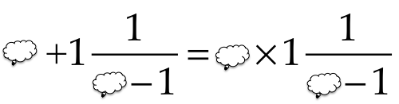

The use of a cloud to stand for an as-yet-unknown number has been found to be accessible even to learners who might be described as algebra-refusers.

The applet is useful because it generates many different random examples chosen from a class of expressions (phenomena) which start on the left hand side with

.

I am deliberately not saying more so as to provoke readers into exploring for themselves.

#### Ways of Working

Because the applet generates sequences at random, and offers the opportunity to have the fractions in brackets either simplified or else displayed so as to reveal the structural relationships, it reduces pressure on the teacher to generate more of their own. However when presented ‘live’ to a live audience, the presenter can vary the choice of examples offered, and the challenges to understanding which the applet affords.

A useful pedagogical strategy for getting people to make sense of something is *Say What You See* (or SWYS for short). Whether what is on the screen is complicated and potentially off-putting at first, or apparently simple but deserving of prolonged attention, learners can be enculturated into a useful way of dealing with phenomena. Individuals in groups are invited to say something that they see without theorising or trying to account for it, inviting negotiation and the raising of questions about whether what someone reports seeing really happened. To use SYWS by yourself requires real discipline, so it is useful for learners not only to experience it frequently in plenary, but in situations where they can see that it makes a significant contribution to sense-making.

Versions of SWYS can be used with very young children, for example with learners as young as 4 or 5 when engaged in pattern-reproduction and pattern-reconstruction tasks (Papic & Mulligan 2007). One way to follow up SWYS effectively is to suggest that individuals make a copy for themselves, but while doing this, to *Watch What You Do* (WWYD). It is often the case that the enactive or behavioural aspect of the human psyche manifests relationships before the cognition or intellect has become consciously aware of them.

Similar simpler versions can be used with younger children (for example using Structured Variation Grids Mason: Mason 2013e) and there are variations which lead to factoring trinomial expressions which can be used with older children (for example Tunja Sequences: Mason 1999, 2005).

### Number Necklaces

von Worley (2012) presents an animation which shows a succession of images of ‘necklaces’ of discs. Every few seconds the next term is generated. Some sample frames are provided below (in the original, in the upper left hand corner, the *n*th frame has the factorisation of *n* into prime powers).

  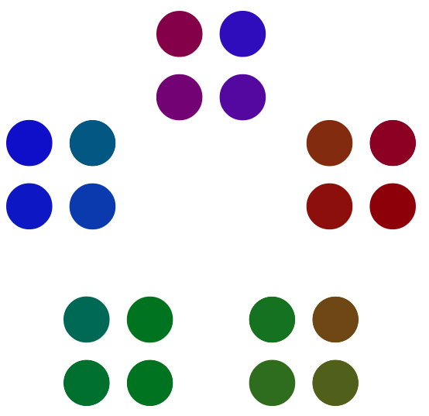 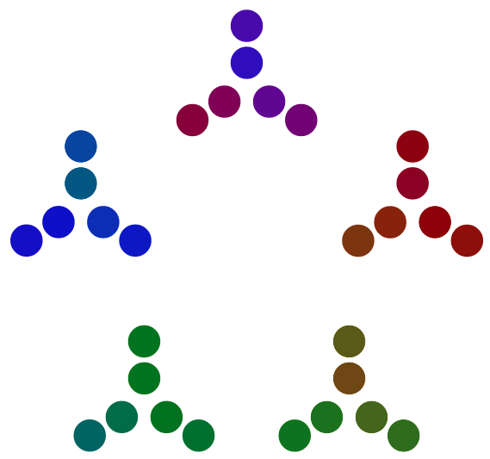

Frames for 9, 14, 20 and 30

In order to experience the phenomenon, it is essential to watch the film. For my presentations I have taken the first 100 images and turned them into a power-point presentation so that I can control the speed and stop it at will. The original simply keeps on going as long as you leave it running.

People tend to watch until the number reaches the thirties, before attention begins to fade. It is not, however, entirely evident, at least at first, how to use the film effectively in a classroom setting. Intriguing as it is at first, the film keeps on going, frame after frame, and viewers may be lulled into a sense of ‘knowing’ without necessarily probing beneath the “endlessly attractive surface” (Calvino 1983). After a while even the surface loses it attraction and people tend to turn away to other stimuli.

#### Ways of Working

In the upper left of the frames there is the frame number and its factorisation, so with or without that information, it is pretty clear that the frames consist of a principled display of the factorisation of positive integers. However, it is one thing to ‘have a sense’ of what is happening, and quite another to bring it to articulation. The strategy SWYS provides a discipline which can help learners resist the temptation to jump to conclusions, but rather to analyse the situation carefully.

SWYS leads naturally to the pedagogic strategy of *narration*: getting learners to bring to articulation (usually in twos and threes when face-to-face) what they think is happening. Twitter or other e-forums could provide further incentive to bring to articulation.

In order to recognise pertinent relationships, WWYD provides a discipline when copying diagrams and patterns for oneself, so as to maximise the chance of detecting and getting-a-sense-of underlying structural relationships (*going across the grain*) rather than simply ‘making a copy’. As George Pólya (1962) pointed out, the purpose of specialising, of ‘doing examples’ is to re-generalise for oneself.

Constructing a personal narrative, and negotiating-refining it in response to other people’s narratives is one thing; predicting what will come next is quite another. A useful pedagogic strategy is *prediction*: getting learners to make conjectures predicting what is coming next. The teacher can demand greater precision than the learners provide at first … it is not easy to learn to do this for yourself! Actually sketching, or constructing in some appropriate software often brings unexpected relationships to the surface. With number necklaces, it is evident that predicting what is coming requires a more intimate structural sense of what is happening than simply the fact of factors being displayed.

In classrooms, it seems desirable that rather than constantly trying to catch up with what the teacher is saying, writing or displaying, students are encouraged to anticipate what is coming. In this way they are conjecturing and may learn from having their conjectures either falsified, or confirmed. Even stronger is the strategy of *reconstruction*: it is highly informative to try to program the film for yourself, because it is in getting the details right that overlooked relationships have to sorted out. For example, the way that factors involving 2 and 4 are treated differently to say 3 and 9.

### Reflected Tangents

For the following task, *do not* draw a diagram! Try to imagine!

Imagine a circle with a point *P* moving on the circle. Imagine also a tangent to the circle at *P*. Imagine further a diameter of the circle *AB*, and the chord *PA* joining *P* to *A*. Imagine the tangent being reflected in that chord. What happens to the reflected tangent as *P* moves around the circle?

Here the phenomenon has been presented verbally, calling upon mental imagery. I have deliberately not displayed a diagram, though in a session I would follow the verbal description with an animation (Mason 2013a).

#### Ways of Working

Experience shows that explicit work on mental imagery develops students’ powers to imagine more and more complex objects (Leapfrogs 1982), and that this stands them in good stead in many activities inside and outside the classroom. One of the associated pedagogic strategies is *no-hands*: outlawing the use of hands and fingers when describing mental images to colleagues helps to develop descriptive powers as well as developing the power to imagine. By blocking diagrams until learners cry out to be allowed to draw something may help them appreciate the role of drawing a diagram in other situations, both mathematical and non-mathematical.

Again, a useful pedagogic strategy is to try to reproduce or *reconstruct* what you have seen or imagined, for yourself. Sometimes this is referred to as a *black box task* (Laborde 2001) because the construction in a dynamic geometry worksheet is hidden from students so they must re-construct it for themselves. It is in the act of reconstruction that there is a shift from simple narrative or over-view to appreciating underlying structural relationships.

The reflected tangents task illustrates the importance of the mathematical theme of *invariance in the midst of change*: recognising relationships that stay fixed while other things are permitted to change. In this case the point *P*, its tangent and its chord are all moving, but there is something invariant about the reflected tangent.

This particular task illustrates the role and significance in geometrical thinking of inserting extra geometric objects in order to make it easier to discern geometrical relationships governing the phenomenon, and to be able to exploit those structural relationships. In the case of a circle, the fact that all the radii are equal can be important, and when there is a tangent, there are angle properties that follow necessarily. *Making the implicit explicit* is a useful strategy not only in geometrical thinking but in mathematical thinking more generally.

(Re)constructing something is an ideal opportunity to ask yourself why things must be as they are. Stephen Brown & Marion Walter (1982) promoted the practice of repeating an assertion but placing special emphasis on different words as it is read, preferably out loud. Gattegno (1970) noted that the natural power to *stress and (consequently) ignore* is the basis of generalisation. The emphasis raises the question of ‘why this and not something else?’ For example, why must *AB* be a diameter (what happens if it is only a chord?); why must there be a tangent to the circle at *P:* why not some line at a fixed angle to the tangent but passing through *P*?

A useful slogan in mathematics is

you don’t fully understand something until you can place it in a more general context.

Put another way, exploration of variations is what opens up a situation as a vehicle for learning, which is supported by the proposal of Ference Marton (Marton & Booth 1997) that learning a concept or a technique is appreciation of what can be changed and what must stay fixed, or in other words, what is available to be learned is what is varied in close time and space. This parallels the observation that a pervasive theme of mathematics is the study of *invariance in the midst of change* (Mason & Johnston-Wilder 2004, 2004a). Thus the study of arithmetic is not the collecting of procedures and the development of facility (useful those these may be) but the growing sense of arithmetic as the study of actions of numbers on numbers, what structural relationships are invariant, in the context of what is permitted change (Watson & Mason 2005).

### Composite Coincidences

The diagram on the left below shows the graph of two functions *C* (cubic) and *Q* (quartic) and one of their two compositions (dotted). It is already a useful exercise to decide which one: *Q*o*C* or *C*o*Q*; the associated applet (Mason 2013c) offers opportunity to deduce that the dashed curve is in fact the composite of *Q* and *C*. The diagram on the right shows some apparent coincidences (both horizontal and vertical). Are these special to the particular functions?

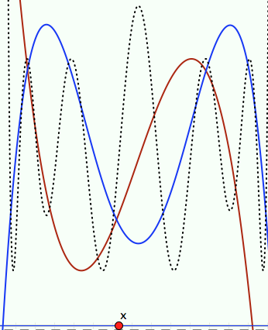 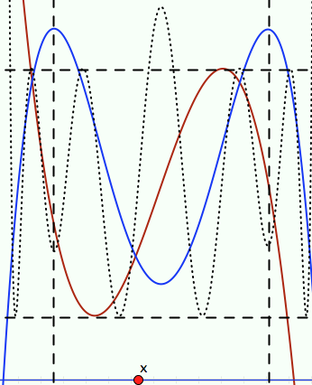

Presenting these dynamically on screen changes the situation from a single instance to a possible phenomenon, brought to articulation through using SWYS. Of course it is mathematically important not to trust such ‘phenomena’ but rather to treat them as conjectures which need to be justified mathematically. The phenomenon generalises considerably, beyond this particular cubic and quartic to pairs of differentiable functions. Furthermore the image adds to the richness of the concept image and to the example spaces that learners are developing concerning the differentiation of composite functions. With access to this or a similar applet, there arises the interesting question of how to arrange the cubic and the quartic so that both composite functions display their expected degree of 12 in the number of oscillations that are visible on the screen. This is but one example of how phenomena presented on e-screens can raise questions that both probe learner appreciation and understanding of underlying ideas, and raise pedagogically-based mathematical questions not apparent prior to the existence of dynamic geometry.

### Invariant Polynomial Chord Means

In the diagram there is a cubic polynomial and a chord through two points *A* & *B* on the cubic. A vertical line is drawn through the midpoint of *AB* (shown with an arrowhead). A tangent is drawn at the point where the vertical line meets the cubic. The tangent appears to meet the cubic again at the same place where the chord meets the cubic again.

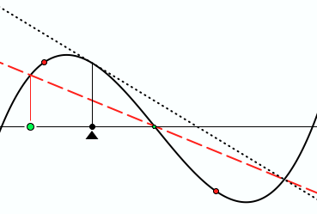

Frame from animation showing tangent at mean of chord intersecting cubic with chord

This is a specific instance of a much more general phenomenon (Mason 2011, see applet Mason 2013). There is a lot happening on the screen and many buttons to try pushing. If a teacher uses the applet in plenary, they can direct attention by asking questions and by animating or pointing. They can make use of pedagogic strategies such as SWYS and narration; they can direct learners to reconstruct for themselves (by hiding the screen image) and they can respond to what learners say and do.

Left to their own devices without prior experience of such pedagogic strategies learners are unlikely to make full and effective use of the pedagogically rich affordances of applets like these. This is the pedagogical challenge that e-screens make, specially for people making pedagogical applets intended for individual use.

### Sundaram’s Sieve

The grid shown below is a window on an effectively infinite grid extending in all directions, and known to have each row and each column in arithmetic progression. If the shaded cell has the value 12, then what will the upper right hand cell contain?

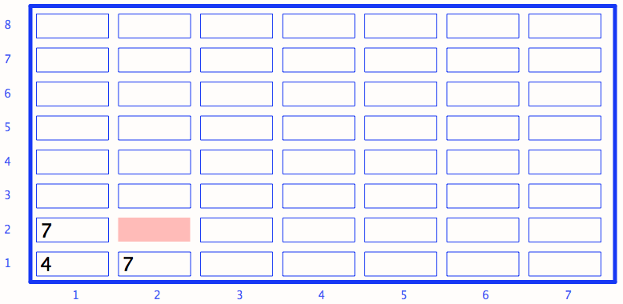

Sundaram (Ramaswami Aiyar 1934; Honsberger, 1970; Havil, 2009) noticed that a positive number appears somewhere in the grid if and only if it is 1 more than a composite number. In order to explore and justify this conjecture, it is evident that it is necessary to develop an expression for the entry in the cell in the *r*th row and the *c*th column. The associated applet (Mason 2013d) not only permits movement of the window over the grid, but can be used in conjecture mode (an entry appears only if it is entered correctly) and in show-me mode (an entry appears when clicked). Furthermore the underlying arithmetic progressions can be changed.

#### Ways of Working

Although it may be tempting to provide learners with their own grids to fill in, resorting to specialising is more effective if it is undertaken on learner initiative rather than being imposed. The grid can be used for stimulating and checking conjectures. Here again SWYS can be used to clarify the underlying structure, and WWYD as cells are filled in (or imagined being filled in) can provide access to the required generality. Time devoted to narration before and during and after filling out the grid supports and prompts expressing of the generality.

## Effective Pedagogic Strategies as Effective Learning Strategies

Phenomena, that is, something happening that is unexpected or surprising can stimulate interest, attract attention, raise questions. But this is at best the beginning. There are plenty of questions around, and plenty of surprising things that happen. However, human beings adapt very quickly, as the rapid development of e-screen interaction demonstrates. Adults and children can become inured to change without asking questions, and certainly without pursuing any questions they do ask.

Sparking interest is one thing, but how can the initial flare up of interest be fanned into a substantive and sustaining fire? This ‘fire-lighting’ image lies at the heart of the seven-phase framework which underpins *Thinking Mathematically* (Mason, Burton & Stacey 1982/2010). It refines the four phases identified by Pólya (1962) and particularly pays attention to what Jim Wilson (private communication) once described as “the most spoken about but least activated of the four phases”.

I have tried to provide a brief experience of several pedagogic strategies which are also learning-strategies, emerging from or arising from using e-screens to present phenomena that can be explained by thinking mathematically.

|  |  |
| --- | --- |
| SWYS  WWYD  Narration and Explanation  Reconstruction (immediately or as revision)  Stressing & Ignoring (selective emphasis) | Reproduction (Black Box)  No Hands  As-yet-unknown number  Making the implicit explicit  Same & Different |

The main contribution a teacher can make is to contribute to learners learning how to learn. In the situations posited here, this means learning how to learn from encountering a phenomenon, by establishing as a practice one or more of the strategies mentioned. In face-to-face encounters, teachers can introduce a strategy and then over a period of time gradually make the prompts less and less direct, more and more indirect, until the learners are initiating the prompt for themselves. This process is known as *scaffolding and fading* (Seeley Brown, Collins & Duguid 1989), or as a trio indicating a spectrum of directness: *directed – prompted – spontaneous* (Love & Mason 1992). One way to become less directive is to shift to meta-questions (Pimm 1987) such as ‘What did you do last time in this situation?’ or ‘What question did I ask you last time?” or even “What question am I going to ask you?” (Floyd, Burton, James, & Mason 1981; see also Mason & Johnston-Wilder 2004). Each is intended to draw learner attention to actions that were effective in the past. If effective actions have been labelled, then not only does the label make it easier to refer to past experience, but it also provides a seed-crystal around which other experiences of effective use of that action can congregate, enriching lived experience and making it more likely that in the future something will resonate and bring to mind associated possibilities. In order to maximise the likelihood of an effective action coming to mind when appropriate it is useful to ‘pro-flect’: when reflecting on what was effective in some situation, to imagine yourself in some future similar situation and having that action come to mind, amplifying the emotional or affective aspect of having an action come to mind, and reinforcing mentally the associated behaviour. In this way the past can inform the future (Mason 2002).

Having introduced learners to a practice, and over time faded it so that learners are beginning to initiate that action for themselves, there is a chance that learners will call upon that action in the future. If they have strong experience of its effectiveness, and a growing sense of situations in which it can be effective, they are learning how to learn.

Strategies can be effective when used sensitively by teachers; each can contribute to learning effectiveness if initiative is taken over by learners themselves rather than waiting for teacher intervention. It seems evident to me that the strategies proposed here are learning strategies that would be of benefit to anyone learning mathematics by themselves or in either synchronous or asynchronous partnership with others. The question remains however, as to how to promote these ways of learning to learn mathematics at a distance, through the use of applets of one sort or another.

## Obstacles to Instituting Practices

In a face-to-face context the teacher is responsible for, and largely in control of the processes. The teacher can direct attention in suitable ways, including prompting reflection through listening (Davis 1996) and through suitable questioning (Watson & Mason 1998). Even though the strategies outlined above, developed as practices, are proven to be effective, there are considerable obstacles to embedding these into work with e-screens.

Consider a phenomenon presented on an e-screen through animation or juxtaposition of several images. Suppose then that the user endeavours to leave that screen. If there is an enforced reflection prompt, the user is at best going to find the prompt helpful the first few times, but thereafter it will become tedious if not irritating. Even a smart program that ‘knows’ when a prompt has appeared several times and tailors the next prompt accordingly, is likely to seem mechanical and artificial with all-too-frequent pop-up reminders to reflect in some way. It is much more likely to annoy and frustrate than to make a positive contribution. For example, even the pop-ups that remind you to make a choice about downloading something from the internet, or prior to opening a file, however well-meaning, quickly become irritating. Programs are not yet good at choosing when it would be appropriate to prompt some reflection, to ask some slightly unusual or meta-question, whereas sensitive responsive teachers are able to gauge appropriateness much more finely.

What can be done to encourage people when working by themselves on an e-screen, to make use of strategies which run counter to their disposition to ‘click and go’ at the slightest obstacle? What can be done to encourage people who do keep struggling with an App to learn more from the experience than how to get to the next level of challenge? These are important research questions for the future.

## References

Brown, S. & Walter, M. (1983). *The Art of Problem Posing*. Philadelphia: Franklin Press.

Calvino, I. (1983). *Mr Palomar*. London: Harcourt, Brace & Jovanovitch.

ITEI Newsletter (2009). CIBER Work Package IV, p21. <http://www.itei-itea2.org> (accessed 2013).

Davis, B. (1996). Teaching Mathematics: towards a sound alternative. New York: Ablex.

Floyd, A., Burton, L., James, N., & Mason, J. (1981). EM235: Developing Mathematical Thinking. Milton Keynes: Open University.

Gattegno, C. (1970). *What We Owe Children: the subordination of teaching to learning*, Routledge & Kegan Paul, London.

Havil H. (2009). Sundaram’s sieve. *Plus Magazine,* 50 (13). Retrieved August 15, 2012 from [www.plus.maths.org/content/sundarams-sieve](http://www.plus.maths.org/content/sundarams-sieve)

Honsberger, R. (1970). *Ingenuity in mathematics*. New Mathematical Library #23, p. 75. Washington, DC, USA: Mathematical Association of America.

Laborde, C. (2001). Integration of Technology in the Design of Geometry Tasks with Cabri-Geometry. *International Journal of Computers for Mathematical Learning* 6, p283–317.

Leapfrogs, (1982). *Geometric Images*. Derby: Association of Teachers of Mathematics.

Marton, F. & Booth, S. (1997). *Learning and Awareness.* Hillsdale, USA: Lawrence Erlbaum.

Mason, J. (1998). Protasis: a technique for promoting professional development, in C. Kanes, M. Goos, & E. Warren (Eds.) *Teaching Mathematics in New Times: Proceedings of MERGA 21*, vol 1, Mathematics Education Research Group of Australasia, p334-341.

Mason, J. & Johnston-Wilder, S. (2004; 2nd edition 2006). Designing and Using Mathematical Tasks. St. Albans: Tarquin.

Mason, J. & Johnston-Wilder, S. (2004a). *Fundamental Constructs in Mathematics Education*, RoutledgeFalmer, London.

Mason, J. (1999). Incitación al Estudiante para que Use su Capacidad Natural de Expresar Generalidad: las secuencias de Tunja, Revista EMA 4 (3) p232-246.

Mason J. (2002). *Researching Your Own Practice: the discipline of noticing*, London: RoutledgeFalmer

Mason, J. with Johnston-Wilder, S. & Graham, A. (2005). *Developing Thinking in Algebra*. London: Sage (Paul Chapman).

Mason, J. (2011). Mean-Invariant Polynomial Intersections: a case study in generalization *Technology, Knowledge and Learning Journal* 16 (2) p183-192. DOI: 10.1007/s10758-011-9185-y

Mason, J. (2013). *Mean Invariant Chordal Polynomials* applet at mcs.open.ac.uk/ jhm3/ Applets%20&%20Animations/ Applets%20&%20Animations.html (accessed Feb 2013).

Mason J. (2013a). *Patterns From 2*. Applet at mcs.open.ac.uk/ jhm3/ Applets%20&%20Animations /Applets%20&%20Animations.html (accessed Feb 2013).

Mason J. (2013b). *Reflected Tangents*. Applet at mcs.open.ac.uk/ jhm3/ Applets%20&%20Animations/ Applets%20&%20Animations.html (accessed Feb 2013).

Mason, J. (1013c). *Cobwebs*. Applet at mcs.open.ac.uk/ jhm3/ Applets%20&%20Animations/ Applets%20&%20Animations.html (accessed Feb 2013).

Mason, J. (2013d). *Sundaram’s Grid*. Applet at mcs.open.ac.uk/ jhm3/ Applets%20&%20Animations/ Applets%20&%20Animations.html (accessed Feb 2013).

Mason, J. (2013e). *Structured Variation Grids*. Applets at mcs.open.ac.uk/ jhm3/ Applets%20&%20Animations/ Applets%20&%20Animations.html (accessed Feb 2013).

Papic, M., & Mulligan, J. T. (2007). The growth of early mathematical patterning: An intervention study. In J. Watson, & K. Beswick (Eds.), Mathematics: Essential research, essential practice. (Proceedings of the 30th annual conference of the Mathematics Education Research Group of Australasia, Hobart), Vol. 2, pp. 591-600. Adelaide: MERGA.

Pimm, D. (1987) *Speaking Mathematically: communication in the classroom*, London, Routledge.

Pólya, G. (1962). *Mathematical Discovery: on understanding, learning, and teaching problem solving* (Combined edition). New York: Wiley.

Ramaswami Aiyar, V. (1934). "Sundaram's Sieve for Prime Numbers". *The Mathematics Student* **2** (2) p73.

Seeley Brown, J. , Collins A., & Duguid, P. (1989). Situated Cognition and the Culture of Learning, Educational Researcher, 18 (1) p32-42.

Von Worley, S. (2012). Data Pointed website, [www.datapointed.net/ visualizations/ math/ factorization/ animated-diagrams/](http://www.datapointed.net/%20visualizations/%20math/%20factorization/%20animated-diagrams/) (accessed Jan 2013).

Watson, A. & Mason, J. (1998). *Questions and Prompts for Mathematical Thinking*. Association of Teachers of Mathematics, Derby.

Watson, A. & Mason, J. (2005). *Mathematics as a Constructive Activity: learners generating examples*. Mahwah: Erlbaum.

Watson, A. (2000). Going across the grain: mathematical generalisation in a group of low attainers, *Nordisk Matematikk Didaktikk (Nordic Studies in Mathematics Education)*, vol. 8, no. 1, p7–22.

1. Everyone [scholars as well as students] exhibits a bouncing/flicking behaviour, which sees them searching horizontally rather than vertically. Power browsing and viewing is the norm for all (ITEI Newsletter 2009).