Magic Square Reasoning
Notes by John Mason
July 2011

Aim
To provide a context for reasoning mathematically without having to do arithmetic computations, and provoking learners into being aware of operations that can be performed on equations.

Setting
A magic square is a square array of numbers for which the sum of all the entries in any row in any column, and on the two main diagonals, is the same.

Task 1: 3 by 3 Magic Square
Why, for any 3 by 3 magic square, must the sum of the red (dark shaded) squares be the same as the sum of the blue (light shaded) squares in each diagram?
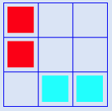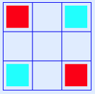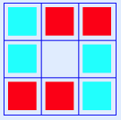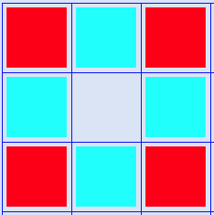
What is the scope of ‘any’ 3 by 3 magic square?
What other configurations can you find for which the sum of the dark/red shaded squares is the sum of the light/blue shaded ones?
Do all colour-symmetric configurations work (interchanging colours is a geometric symmetry)?

Task 2: 4 by 4 Magic Squares
Why must the sum of the dark/red shaded squares be the same as the sum of the light/blue shaded squares in each diagram?
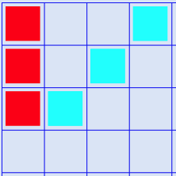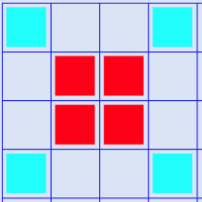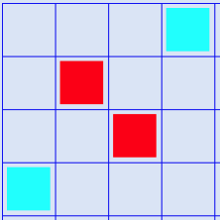
What other configurations can you find for which the sum of the dark/red shaded squares is the sum of the light/blue shaded ones?
Do all colour-symmetric configurations work?

Task 3: Is It Magic?
How many of the row, column and diagonal sums have to be known to have the same value in order to be able to deduce that the square must be magic? In otherwords, can you have a non-magic square for which just one row has a different sum to all the other rows, the columns and the diagonal?

Notes
The constant row, column and diagonal sums are like axioms; Removing cells common to a row and a column preserves the equality of sums.

