Towards a National Framework
for CPD in Mathematics:
Sources, Resources & Language
for
Working On Mathematics Education
OU CPDFW Group
Version 6

Contents of Document
1. FW Requirements (Aims, Constraints, Outcomes, Legacy)
2. Structure of Effective CPD, (Tripod image)
3. Structure of the Full FW
FW Core (CPD Directory; PedMaPedia; User Community)
FW Surface (access routes into the databases)
4. Justification for the Structure
5. PedMaPedia Details

1. FW Requirements
The CPD Framework in Mathematics (CPD FW for short) is envisaged as an iteratively dynamically evolving web of interconnected pages, much of which is augmentable by the community of people concerned with and about the teaching and learning of mathematics 0-18 so that there is a growing sense of community and professionality.

Aims
The CPD framework should
- provide access for any teaching assistant, teacher, consultant or educator to what CPD and associated resources are available for them in their situation concerning the teaching and learning of mathematics;
- appeal to the immediate concerns of teaching assistants, teachers, consultants and educators, in all phases of their careers;
- provide evidence of gaps in current provision (NCETM needs to be able to tickle the database to reveal gaps and to alert PD agencies to these needs);
- act as a source and stimulus for research and development;
- act as a stimnulus and generate enthusiasm for, ongoing PD
- promote integration of the effects of
working on mathematics for oneself and with others,
extending the range of pedagogic tactics available,
deepening awareness of the ways in which didactic (topic specific) devices can enhance learning,
articulating and challenging implicit assumptions, principles and theories which are driving practice, so as to be able to justify, develop and modify these;
through embedding these in practice with the support of colleagues working collaboratively.
This forms the basis of the Professional Learning Framework also referred to as the Tripod Image, being based on these three ‘legs’: mathematics, pedagogy & didactics, and embedding in practice
- promote formation and sustaining of networks (local and national) of collaborating professionals, centred around common interests and concerns;
- provide a rationale for continuing professional development as a necessary component of professional practice;
- provide a rationale for the structure of the framework for those interested, in order to inform future development of the framework;
An effective CPD Framework will
- attract all those concerned with the teaching of mathematics to continue to develop their professional practices;
- assist schools and colleges in supporting and promoting the sustained and career-long professional development of its mathematics staff;
- supporting valid, reliable and consistent decisions regarding performance development, pay and career progression where applicable and in relation to the standards described by the appropriate bodies (TDA, GTCE, LLUK etc)
- help to identify professional development needs provide a reference point for teachers as they review and plan their development and inform their self evaluation;
It follows that as well as providing a Directory of PD provision for all those involved with mathematics, together with a Directory of material resources which support or promote learning of mathematics and a virtual community of comment and insight into issues concerning the teaching and learning of mathematics, the FW must, if it is to be useful, provide sources of stimulation and support for PD. To this end, the concept of a FW needs to be extended to include access to a constantly evolving language for describing, planning, and informing teaching and learning of mathematics.

Constraints
The CPD framework for mathematics must
- appeal to teachers, teaching assistants, consultants and educators in all phases and at all stages of their careers, in order to promote PD as a professional responsibility as well as personal stimulation and fulfilment;
- keep up to date with government initiatives, changes in practices, and developments in research findings;
- fit with TDA standards and chartered teacher standards as these evolve;
- be maintained and updated on a weekly/monthly/termly basis as appropriate for the level of detail;

Tensions
To be successful, the CPD framework has to span a spectrum from PD as a right and a privilege that all teachers naturally want in their work setting, to a duty to keep ‘up to speed’, to keep up to date as an appropriately qualified professional.
The CPD Framework will be successful if it manages to influence both the community and the funders of the community that CPD is essential and both a career-long right and responsibility.

Outcomes
Evidence of success would include
- significant numbers of teachers reporting access to PD which energises and refreshes them and their teaching
- teachers granted an entitlement to CPD throughout their career
- increase in take-up of maths at A-level, undergraduate, and PGCE;
- decrease in the as-yet-unreached by CPD
- decrease in the % of unqualified mathematics teachers
- increase in reported job satisfaction
- increase in the number of teacher networks and complexity of the web of these networks
- increase in active membership of subject-specialist associations
- evidence of sustained and long term development as part of the ethos of teaching mathematics
- increase in teacher willingness to depart from published schemes and lessons as they tailor tasks and interactions to their particular learners’ needs
- greater clarity in what constitutes a developing and committed professional teacher concerning mathematics.

Legacy
By the end of the development phase the CPD framework could
- be supporting coordination of CPD provision by a multitude of agencies;
- demonstrating how PD can be sustained and developed as a vital component of maintaining and improving the educational experience of learners;
- be developing with a natural life of its own, integrated into the mathematics education community

2. Professional Learning FW
Professional Development provides both support and impetus for continuing to learn as a professional. Teaching, and the support of teaching in its many guises, from teaching assistants to initial teacher education to research, is a lifelong process of learning and developing. Massive accumulated experience in mathematics education, including extensive research into supporting and promoting effective teaching, all underlines the necessity of three kinds of complementary activity.

The Tripod Image of Effective CPD
Any CPD for teachers and lecturers of mathematics should comprise three components: mathematics content knowledge, subject specific pedagogy and embedding in practice. CPD should be cumulative and sustained over a period of time leading to appropriate recognition and/or accreditation. A major role for the NCETM is to achieve coordination of provision across agencies in order to address national priorities [DfES Chief Advisor for Mathematics, policy paper]  This tripod structure can be elaborated in more practitioner friendly language, as shown to the right: | 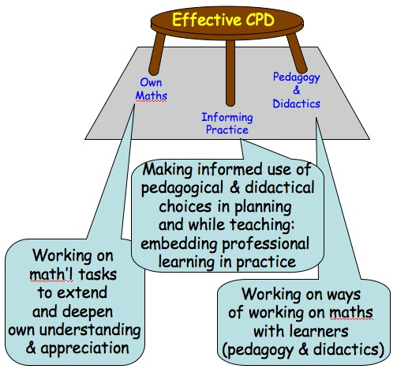
The tripod emphasises the interconnectedness of the three strands, and the necessity of each for effective professional development. The FW promotes the tripod metaphor by using the three legs to structure entries in the databases.
The terms pedagogy and pedagogic are used to refer to strategies and tactics which can be used in almost any topic and in almost any lesson. By contrast, the term didactic is used to refer to issues of teaching a specific mathematical topic. Thus the use of the empty number-line to work on counting-on is a didactic issue, whereas pausing to get learners to discuss something amongst themselves, or to construct a mathematical object like one under discussion are pedagogic strategies because they can be used in any lesson and with any topic.

Psychological & Sociological Heart of Effective CPD
The recent CUREE systematic review of the impact of networks on pupils, practitioners, organisations and communities reaffirmed what has been known for two generations at least: features of networks linked to positive impact involved fresh impetus , use of external expertise, and development of self-sustaining capacity over time; collaboration (colleagueal support) is critical; clear aims; involvement of participants in the choice of aims and developments.

The key questions for any PD participant are “Do I recognise this issue?” and “Can I imagine myself doing … in my situation?”. This means that the key question for PD providers is “How can I support practitioners in recognising and experiencing a disturbance, and imagining themselves acting differently in the future?”. | 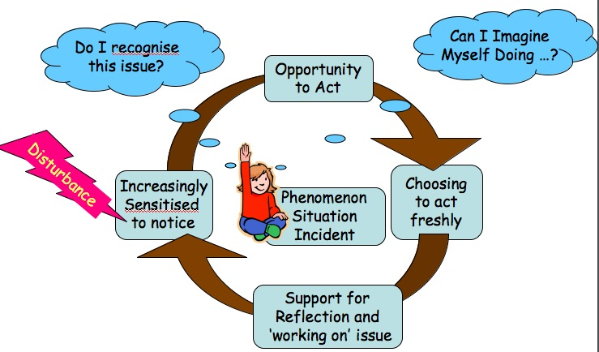
Practitioners who develop professionally are those who experience the need to ‘work on’ some issue, to try things out, to seek the support of colleagues in trying to articulate what the issue is for them, exemplifying it, and describing what they observe when they try alternative actions increasingly systematically.
An important role for the NCETM, through its regional coordinators and website, is to prompt PD providers and Collaborative Networks to promote the notion of ongoing ‘working on’ issues and ideas (including working on mathematics for oneself as well as pedagogic and didactic aspects) and promoting the use of the CPD FW as a source of stimulation and support.

3. Structure of the Full CPD FW
This description of the CPD FW describes the core of the framework, and some of the categories in each of the three components. For more details see the later sections. From the manifestation point of view, the structure of the website is a single integrated database; from the users point of view, there are identifiable components in order to facilitate and prompt access to different components for different interests. The issue of surface access routes into the CPD FW is developed in a later section.

Core
The core of the SR&L is a comprehensive database of CPD activity in three components:
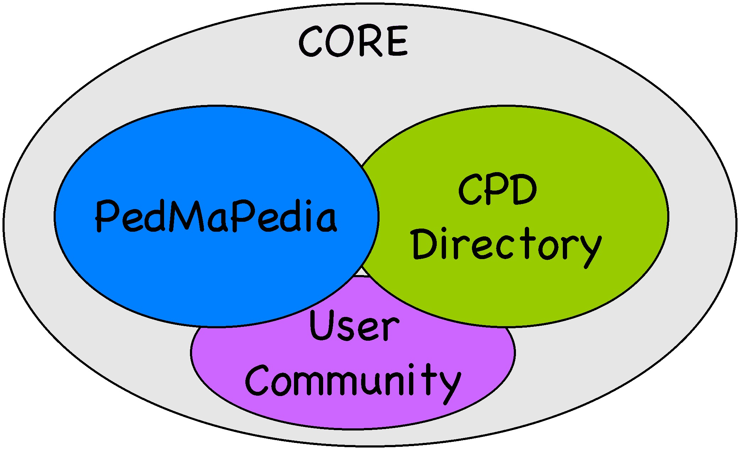

CPD Directory: Networks, Agencies, Courses, Events & Material Resources
A dynamically evolving database (incorporating but extending the current NCETM database) which is timely and interlinked with the other databases so as to form a richly informative and inspiring focus for CPD; it lists and gives access to networks of collaborating colleagues (from small groups of collaborating colleagues in a school or cluster of schools, to subject associations and other interest groups providing linked local and national contacts), agencies providing PD of various forms, events, and other sources of PD support; includes how to contact, get involved, or access archived content; it also includes a directory to sources of material resources of different kinds.
Each entry of the database will have information about how the group, agency, course or event contributes to the three components of the CPD tripod, with links out to places where extra support in those dimensions can be found. There will also be links into and out of the PedMaPedia for issues about choosing, using, and augmenting materials, ways to justify and conceptualise choices, etc. and links into and out of the User Community for relevant comments and discussion.
The following diagram shows some of the categories of entries in the CPD Directory section.
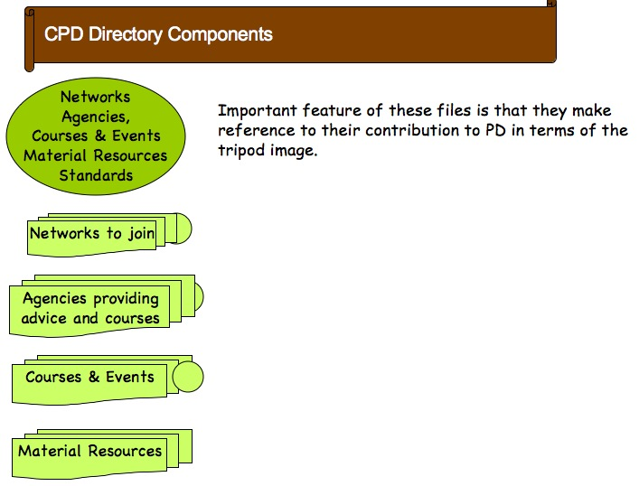
Some examples of the sorts of links that are included:
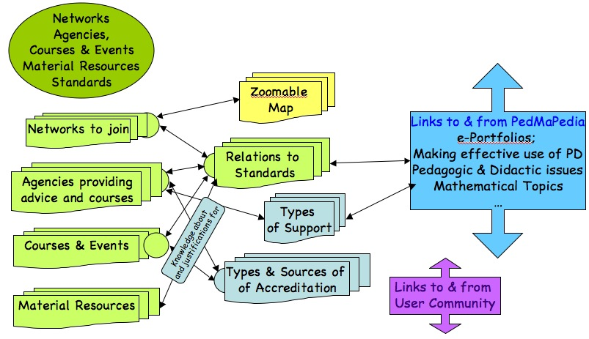
Categories in the CPD Directory
(Not all outward & inward links are indicated)

PedMaPedia
This is a Wiki (see http://en.wikipedia.org/wiki/Wiki) consisting of a dynamic, evolving richly inter-connected and out-connected encyclopaedia of pedagogical mathematics and mathematical pedagogy (hence PEDagogical MAthematical WikiPEDIA: PedMaPedia) which provides access to encyclopaedic information about pedagogic strategies and didactic tactics with research evidence, research questions, access to principles and theories which both inform and justify choices and actions; advice on how to initiate and sustain collaborative groups, how to get the most out of PD courses and events, how to develop an e-portfolio, issues and concerns about teaching and learning mathematics etc..; [See last section for elaboration]
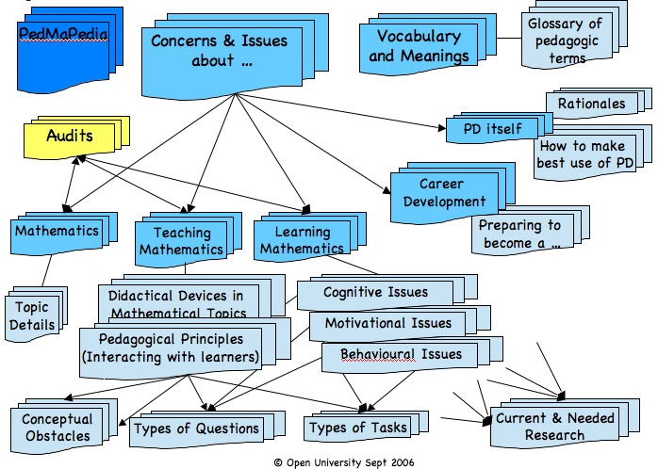
For an example of e-portfolio support and case studies, see http://gallery.carnegiefoundation.org
For more detail, see last section.

User Community
an interactive site for users including commissioned Blogs and reports from users; also included would be direct access to pertinent government initiatives in curriculum and assessment strategies and structures.
In order to foster and sustain a sense of community of professionals, a place is needed for commissioned Blogs, for comments on PD (What PD did for me), for people seeking help, support or contact etc.. Comments need to be time-limited but retained for possible future use as a stimulus of some sort. Comments need to be linked both ways to the CPD Directory. There need to be automatic ways for people to refer to and to be linked into from pertinent PedMaPedia entries so that users can enrich their discussions and find people discussing issues of interest to them. There also need to be links into and out of the CPD Directory.
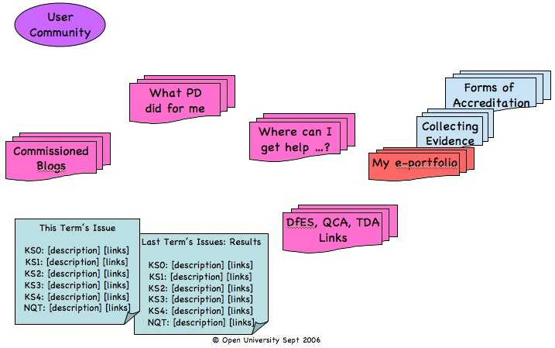
Registered users would have their own home-page with preferences, and receive email reminders (with a clickable html reference) to remind them to visit the site for updated information about particular points of current interest relevant to them etc..

My e-Portfolio
A place to keep track of PD activities undertaken; reference to learner’s work collected for reflecting on and researching into; Automatic updating from tick boxes on Course/Event records in the CPD Directory

Commissioned Blogs
Each term each KS, a teacher is commissioned to keep a weekly Blog of (some of) the pedagogic and mathematical choices they have made that week.
Could have a ‘day in the life of’ Blog as well, featuring well known figures or people in specific roles other than teachers.

What Inspired me; What PD Did For Me; Comments on PD
A place for comments about trials and tribulations, successes and insights achieved through and during PD activities. Needs to be monitored and archived for future use. Connected to from Courses & Events and from Material Resources

Where Can I Get Help?
An online site for seeking help about specific issues. Needs to be monitored regularly.

Consultations & Polls
Opportunities for NCETM to gather information about opinions and views on everything from national issues arising in the media to the activities and website of NCETM.

Surface Access Routes
Important but delicate aspects of the FW are the ways of attracting people to get involved in CPD through accessing the databases. Some users will know what they want, and so expect direct access; some will want to be stimulated or prompted. What users want to know will be many and various, and so different types of access routes are needed on the surface. The test of relevance of an access route is whether it speaks to some people’s experience sufficiently to attract them in and so that they find something that stimulates their practice and their reflections.
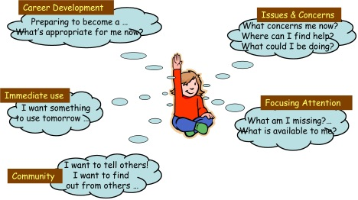
The picture shows some samples. Each connects into more detailed pages with multiple links to the three core-components. Details are elaborated in the file Surface Access. Access routes are necessarily overlapping so the overall structure of the FW Surface will be a network not a tree.
It is vital for returning users always to have direct access into the heart of the databases via some sort of framed menu items.

Typical Page
Here are elements of a typical page.

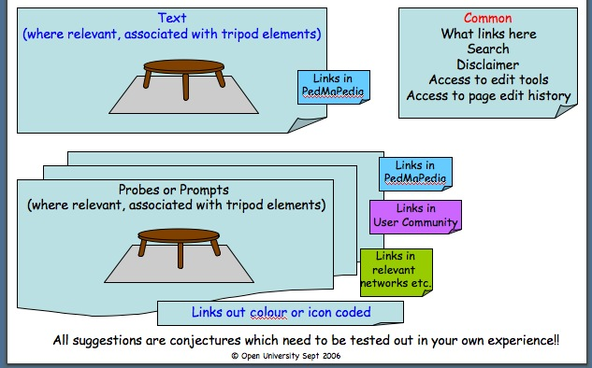

4. Justification for Framework Structure
The key issue is attracting people who are currently PD-shy to make use of the FW, and to attract people back to the FW. To this end the FW has to represent and amplify the sense of community, that everyone concerned about mathematics, its teaching and its learning, is involved. It also has to reflect and resonate with the issues and concerns felt by groups of people involved in different aspects of mathematics in schools.
The PedMaPedia will support this through being open and openly editable and through providing access to the wisdom of the community as presented by the members of the community themselves. A sense of identity as a professional involved in teaching and learning mathematics will only develop where professionality is anticipated, expected and celebrated. This means trusting colleagues to contribute sensibly, with of course some monitoring of contributions in a history file associated with each page so people can see what has happened to contributions.
The PedMaPedia will grow as the community becomes involved. Its directions of rapid growth at any one time will serve to indicate where there is current concern, and its directions of slow growth will suggest where there may be need for further stimulation.
The Wikipedic structure is vital to encouraging the community to take ownership of the entire enterprise. In order that the PedMaPedia develops usefully, so that people want to return again and again, the entries need to have a high density of interconnection with other entries, in the Directory, the Community and the PedMaPedia itself, and those entries need to provide a mixture of very practical, theoretical justifications, and prompts to further enquiry.

5. Some Further PedMaPedia Details
The PedMaPedia a richly interconnected encyclopedia of pedagogical mathematics and mathematical pedagogy (Hence Ped Ma Pedia). It will be structured along the lines of the Wikipedia, with user-augmentable records. Each entry needs to be at most a screen full, and to have cross links, links out to the web, and links to the rest of the database. A tentative substructure is given below.
The PedMaPedia will make a significant contribution to the development of mathematics education and to the development of a sense of professional community amongst all those involved in mathematics in (and pre-) school by providing access to pertinent and significant issues which teachers meet. It will provide advice on making mathematically relevant and pedagogically effective choices together with ways to articulate and justify those choices. It will challenge current practice and prompt users to probe more deeply beneath the surface of their professional practices. It will provide advice on how to initiate and sustain effective and informative PD, and how to develop a career in the domain of mathematics teaching and learning.
A natural question might be why this is needed when the Wikipedia already exists. The answer is that the PedMaPedia has a more limited aim, namely to develop the domain of mathematical pedagogy and pedagogical mathematics, and a more focused aim, namely to serve the community of people concerned with and about mathematics teaching and learning in the UK. It will have much more detail about pedagogical matters than is currently available in the Wikipedia, and as such it could be considered as a contribution to the Wikipedia, but it is unwise to have everything within a single e-domain. Here we can have control over the usefulness for our teachers (and related concerned people) and most particularly, over the links to specifically UK-based networks, agencies and other PD opportunities.
The categories and the forms for populating with records are still under development. A partial list of items is appended: some of these will spawn multiple records, others may form individual records.
Access to items in the PedMaPedia will need to be by
Items from the Surface Access Routes
Simple and Boolean Search
Index of Items
Drop-down or pop-up index of categories

Categories of (Collections Of) Record Items
This is for the moment at least, an unstructured database consisting of a large number of interlinked nodes, grouped into categories so as to aid search and indexing, with a few illustrative examples.
Issues & Concerns … | Descriptions of concerns raised by TAs, NQTs, teachers, coordinators, HoDs etc. together with links to ways of addressing these concerns (Networks, Agencies & Events, research evidence, advice on how to, Pros & Cons for …).  Probes for inviting people to consider these, and to use with colleagues to get them to collaborate in considering them.

… about Mathematical Topics
links to dictionaries for meaning of various terms (and where they are described in the National strategy and QCA documents)
Didactical issues about use of devices; links to general pedagogical possibilities

… about Teaching Mathematics

Planning Lessons

Types of Tasks
A collection of examples of types of mathematical tasks and what they can be expected to achieve
Examples
Sorting tasks (Malcolm Swan’s DfES work)
Construction tasks
In How many Different Ways Can You …

Interacting with Learners
By KS, by type: Types of questioning; promoting discussion and other interaction; design of tasks; types of tasks (Prestage & Perks; Watson); lesson planes; Changing Your Practice; Motivating and engaging Learners; Joining or forming a Collaborative Group;
Asking Questions Mathematically
Promoting Pedagogically Effective Discussion
Working with second language students on mathematics
Mixed Ability Teaching
Teaching Inclusively
Challenging all learners appropriately
Use of specific didactic devices (empty number-lines, dynamic geometry, spreadsheets, number fans, stoplights, white boards, interactive smart boards etc.)
Motivation and truancy

… about Career Development

Preparing to Become a …
Advice on what sorts of things to work on and what sorts of CPD evidence would enhance a portfolio in order to become a
Examples
Teaching Assistant
NQT
Advanced Skills Teacher
Maths Coordinator
HoD (or deputy)
PD provider
Mentor (for PGCE, NQT, … novices)
PGCE Tutor
LEA Consultant
Research Assistant
Research Fellow
Links to TDA and other agencies with statements of standards and expectations.

… about PD itself

How to Engage in and Benefit from PD
A collection of items offering advice on how to engage in PD yourself and with colleagues.
Examples
How To Initiate a collaborative group of colleagues
How to Sustain a collaborative group of colleagues
How to Embed some ideas into your practice
How to Create a portfolio of CPD evidence
How to sensitise yourself to learner difficulties
Links to research items, other resources

Rationales for PD
A collection of justifications and inspirations for engaging in PD
Links to User-Community reports on What PD has done for me etc.
Examples
Why engage in PD?

Rationales for this FW
A collection of justifications for the current structure so as to inform future development and modifications
Examples
Aims and Intentions of the FW
Effective PD (tripod image) justified
Obstacles | A collection of classic learner obstacles which give rise to confusions and mistakes. References to research literature, to classic research probes, and to proposals for circumventing  Examples  Whole numbers, fractions and decimals are different things  Reference to sorting tasks (Malcolm Swan DfES work)  .
 | Conceptual: classic confusions such as ratio-proportion, ratio is additive; if in doubt use linearity; Multiplication and addition make bigger; division and subtraction make smaller; formula are for memorising not manipulating; 0.12 > 0.3; adding tops and bottoms of fractions; Fruit Salad Algebra (a is for apples rather than the mathematically correct a is for the number of apples); …
 | Emotional: fear of failure (I can’t ––> I don’t but I could try to); accepting low expectations of teachers, parents and institutions; Lack of Time; Lack of Opportunity; Lack of Freedom; …
 | Behavioural: needing time to think things through; … Anticipating and Falling behind; concentration spans; physical coordination;
Pedagogical Strategies | Examples: Same & Different; Another & Another; Interchanging Given and Sought;
Didactical Tactics & Devices | A collection of (descriptions and pictures of) of physical devices briefly described, with  Brief description of types of situations in which they are useful;  Theoretical bases for their use;  Questions worth considering about how they are used;  Links to where there is more information about research and practice (including in the National Strategy etc.).  Examples:  white-boards; number fans; dynamic geometry; empty number-line; balance metaphor for equations; Dienes and multibase blocks; unifix cubes;  interactive-white-boards, LOGO, Spreadsheets; Graphical software; calculators; Four Function calculators; specific software etc.; interlinkd with specific mathematical topics;  Say What You See; Watch What You Do; Tracking Arithmetic; Reading Graphs; Interpreting Data; Reading Statistical Displays;
Pedagogical Constructs | Examples:  Dimensions of possible Variation & Range of Permissible Change; Do-Talk-Record; Manipulate–Get-a-sense-of–Articulate; Enactive–Iconic–Symbolic; Directing Attention; Instrumental & Relational Understanding; Pirie-Kieran (onion) model of Understanding; Exercise as Object; Structured variation; Scaffolding & Fading; Structure of a Topic; Stressing & Ignoring; Posing Problems; Fluency & Facility (diverting attention so as to gain these); Didactic Transposition; Theorem-In-Action; Collaboration & Cooperation;
Mathematical Themes | Examples:  Invariance in the Midst of Change; Doing & Undoing; Freedom & Constraint; Extending & Restricting; Changing (re)Presentation; Modelling; Expressing Generality
Vocabulary  Glossary | Brief elaborations with links to research, outside web links.  Examples: constructivism; didactic; pedagogical; purpose & utility of tasks; understanding; Purpose & utility of tasks; Inner and outer aspects of tasks; Promoting collaboration (amngst learners; amongst colleagues)  See http://cme.open.ac.uk/memes/MEMEs_Glos.html for beginning
Study Skills  (Mathematical) | Examples:  Imagining & Expressing; Specialising & Generalising; Conjecturing & Convincing; Constructing own examples; Easy, Hard, General (Bills);
Beliefs & Assumptions | Articulations of beliefs and assumptions that people often make about mathematics teaching and learning which, when brought to the surface and articulated, may be reconsidered or refined.
Research database | A linked bank of research papers and other reading – each item linked from if not to relevant aspects of the PedMaPedia

Ways of Working on Teaching
Mathematical Topics | Additive Domain: topics, reasoning and thinking  Multiplicative Domain: topics, reasoning and thinking  Mensuration Domain: topics, reasoning and thinking  Geometrical Domain: topics, reasoning and thinking  Data Handling and Display Domain: topics, reasoning and thinking  Algebraic Domain: topics, reasoning and thinking  Graphical Domain: topics, reasoning and thinking

A Sample Draft Page
Label | Roaming While They’re Working
Full Title | Ways of interacting with learners as they are working individually and in groups
Category | Pedagogic Strategies
Protasis / Strapline | Teaching is knowing when to “step in” and when to “step out”.
Intro text | The purpose of inviting learners to work on mathematical tasks is to set up conditions in which teaching is effective, through interacting with learners. Roaming the classroom while they are working can be supportive when there is a conjecturing atmosphere, but it can also inhibit learners’ experience if they see it as checking up on them, trying to “catch them out”.
Main text | When students are working on tasks that you have offered them much can be gained from roaming while they are working and adopting a balance of observation, response and intervention.  When teachers respond to student’s requests during the main part of the lesson this can often result in the dialogue being of the “Please Miss, I’m stuck” variety. This forces the teacher into giving suggestions and answers rather than getting the learner to think.  Roaming and choosing to intervene with a question can produce subtle shifts in the sort of dialogue that is going on and in the culture of the classroom. One of the benefits is to promote thinking about the mathematical concept behind the tasks rather than focusing on getting through the tasks “by hook or by crook”.  The sorts of questions you could ask include:  General: how are you getting on?  Mathematical theme: what’s the same and what’s different about …  Mathematical process: How are you doing this? Might there be other ways? In how many different ways …?  See also Scaffolding & Fading; Training Learners to be Independent; …
Probes & Prompts | Do your learners become aware of the questions you ask which are effective in moving them on? (see meta-questioning).  Do you ask questions which narrow or direct learners’ focus on the task, or which provoke them to become aware of more general mathematical strategies, tactics, and powers?
Other Links Out | Ref: Working on versus working through questions.  Ref: didactic transposition  Ref: Inner & Outer Aspects of Tasks
Links In | Ref: Classroom Interaction  Ref: Organising the classroom for learning rather than for control
Research Sources | Ref: David Clarke; Shell Centre
Relationship to Tripod | In order to internalise types or styles of questioning and other effective interactions with learners, it can be very helpful to have a group of colleagues who meet occasionally to work on pedagogical issues (Ways of Working on Issues; Initiating Collaborative Groups;  It can be of real benefit to work on mathematical tasks for yourself, with colleagues with whom you can reflect on the kinds of thinking processes and personal powers you used, and what sorts of interventions were or could have been helpful or disruptive.
Comments
Authors & Sources | Pete Griffin; John Mason

Audits
The aim of the CPD FW is to encourage, foster and sustain the growth of a sense of community of professionals. Professionals do not, on the whole, need tick-boxes and tests to tell them where they might put their attention or address issues. Some issues and concerns they will already be aware of, and the CPD FW will provide access to resources of all kinds (people, materials, and ways of thinking and articulating) to support relevant personal professional development. Many if not most of the PedMaPedia pages will have prompts or probes (preferably randomly chosen from a list for that page) which are intended to provoke reflection on and re-consideration of habits and practices, as well as providing links to pages which give more advice about ways of working on pedagogical and didactic issues.
Examples | What is the difference between labelling behaviour and labelling the person for you, for colleagues, for the person? (examples)  What would you most like learners to do in your lessons?  What do you expect learners to do with examples that you give or work through with them? What do they expect to do with those examples?  What differences are there in how you work with learners who are achieving very well, well, moderately, poorly?
All professionals, by the very nature of professionality, which involves continuing development of ways of thinking as well as changes in or enhancements of practice, are subject to needing outside stimulus and impetus to probe aspects of practice, beliefs and thinking which have not been opened to inspection recently (See CUREE review of literature on impact of CPD). New ideas, fresh discernments, new ways of thinking, fresh practices are a feature of every professional community. Consequently the CPD FW will provide provocative stimulation and fresh insight, as well as access to other sources for this.
In particular, the notion of an audit has to be formulated in profession-sympathetic ways. Teachers, for example, do not want to undergo long tests of their mathematical competence. In addition to access to sources of support for areas or topics (whether mathematical, or didactical or pedagogic) which they are aware is not as string as they would like, they may want to encounter surprises which make them think about and pursue aspects which they discover are not as comprehensive as they might be.
The Extant Primary Audit is an excellent start to providing probes for those who are aware that they need to strengthen their understanding and appreciation of mathematical topics, techniques, and both didactical and pedagogical issues.
KS Maths | A suite of audits on specific aspects of mathematics, not just competence but questions designed to probe understanding. Each could have a final section inviting reflection and pointing out features of the types of tasks in the audit and what they are likely to reveal. I suggest that we must aim to have a maths engine available so that users can enter simple mathematical expressions to be checked automatically (see for example the AIM project  http://maths.york.ac.uk/moodle/aiminfo).  These would develop over time responding to user requests and governmental initiatives.  Content Knowledge: some are topic specific  Mathematical Thinking: AT1 Problem solving; Reasoning, justification and proof; communication
We propose however that the Exemplified National Standards, suitably searchable and with links out to elaborations and other items in the PedMaPedia provides a sufficiently rich source of impetus and advice to those seeking career advice. In particular, the combination of ‘This terms’ Issues’ on which the NCETM collects observations from the user community, and the collection of items under Obstacles in the PedMaPedia will provide a suitable base for challenging, stimulating and provoking further PD by users.

Some Features of an Effective Audit
Person-specific so that work can be interrupted and returned to
Random element so that questions are not always identical (random choice of numbers; random choice of probes)
Small blocks of (say) 5 probes per section
Links in each section to PedMaPedia and Directory for sources of support
Conceptually oriented rather than competence-proficiency oriented, hence immediate links to Cognitive Obstacles section of the PedMaPedia.
There could be an audit of some sort each term with prizes; it might require accessing several records in order to get the answers, but without being able to do a simple search for stock phrases.

Probing-Deeper & Self-Audit Home
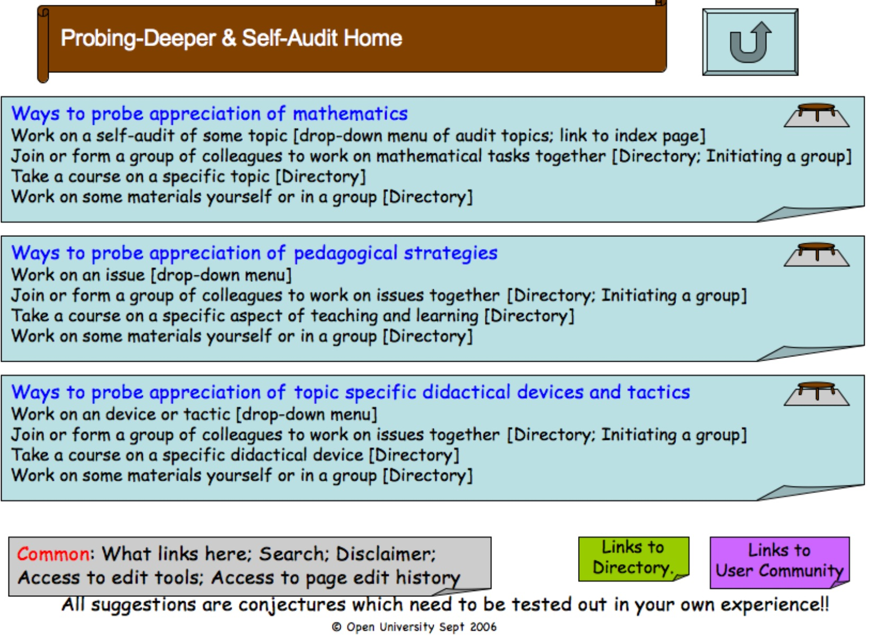
A professional approach to self-audit is to go to a collection of issues and try to articulate my personal approach to dealing with those issues prior to finding what others think, do, etc..


