Over-All Notes for
Pebble Arithmetic
John Mason 2013
The philosopher J. S. Mill proposed something called Pebble Arithmetic so that learners could enactively ‘see’ and ‘touch’ the factoring of quadratic expressions, and thereby augment and enrich their symbolic expression. I came across the idea in a book by David Bloor (1967), then re-constructed it from memory. Later I checked, only to find that Bloor had combined Mill’s idea with an idea of Zoltan Dienes (1960) for displaying the factoring of quadratic expressions. My reconstruction went beyond what Mill, Dienes and Bloor had presented.
Gottfield Frege (1884: §7-10, p23-25) was, as a Platonist, entirely opposed to Mill’s attempts to use material objects, although Plato praised the Egyptians for using material objects in teaching arithmetic (see Hamilton & Cairns 1961 p.)
Pebble Arithmetic A is intended to be used with Factor Walls (an applet) and Number Necklaces (an animation), to compare and contrast different ways of experiencing number factors.
Making these applets has led to generalisations and extensions, creating a rich domain of explorations based around factoring.

Films
There is a collection of films taken from the applets which can be used on any hand-held device. The films are short and silent. What makes them potentially rich is the way in which they can be used with learners as an introduction to expressing generality, which lies at the very heart of school algebra. Samples can be found embedded in the text associated with the different applets.

Ways of Working
The way of working with animations described below is a variant on a way of working developed by Caleb Gattegno for working with his animated geometry films based on those of Nicolet (Tahta 1981). The same protocol can be used with animations, posters, sets of exercises, diagrams and also with classroom video when working with teachers.
View one of the films.
Invite participants to reconstruct the film from memory. Then get pairs to compare their descriptions, or in plenary to re-construct the film from memory, episode by episode. This will reveal differences in what was noticed, and even differences in what happened or in what order. Of particular importance is to note the changes of colour of the pebbles. The aim is to be prepared with questions so as to justify re-viewing.
Re-view if desired or necessary.
Predict what will happen in the next episode. Often it is valuable to see only some of the episodes comprising animation so as to have something to predict and check. The value of the applet is that you can arrange to see other episodes beyond the ones in the film, and you can adjust various parameters to yield different variations on the same idea.
Predict what will happen in some as-yet-unspecified episode. Try to formulate a generalisation that includes different parameter values yielding related but different sequences.

Applets
There are four applets
JSMill Pebbles
Pebble Arithmetic Sequences
Double Pebble Arith
Triangular Pebble Arith

JSMill Pebbles
There are four different types of sequences (Types A, B, C and D). Within each of these there are parameter choices. The parameters are often, but not always, the same as the a and b listed under parameters, which are used for the expression of generality associated with each type. Rather than try to makes sense of the types, it is much more instructive, and fun, to try to express the generalities for yourself by watching several of the sequences.
To run the sample films, double click on the picture.

Type A
Episodes start with a rows of n (n > a) and b rows of a. They rearrange themselves, through b row moves, into a rows of n + b.
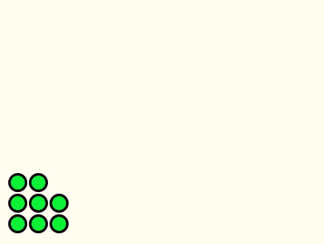
Basic Pebble Arithmetic Example type A

Type B
Episodes start with n – a rows of n and b rows of n – a. They rearrange themselves, through b row moves, into n – a rows of n + b.
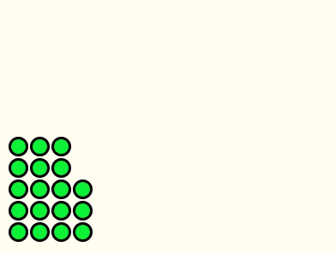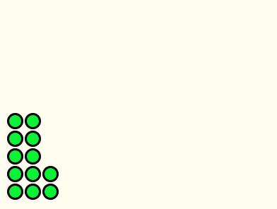
Two examples of type B
The films below are type B and illustrate Mill’s original idea with variations.
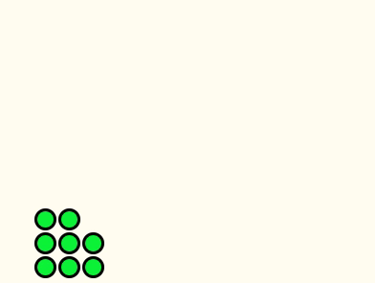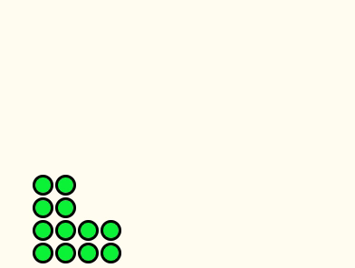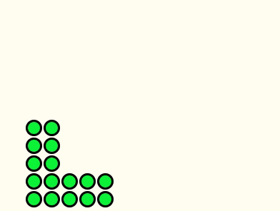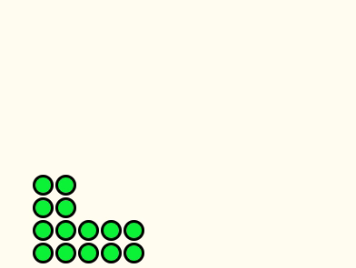
Mill’s original idea and three variants

Type C
Episodes start with n – a – b rows of n and b rows of a . They rearrange themselves through row moves into n – a rows of n – b, and vice-versa, illustrating the factoring of n² – (a + b)n + ab = (n – a)(n – b).
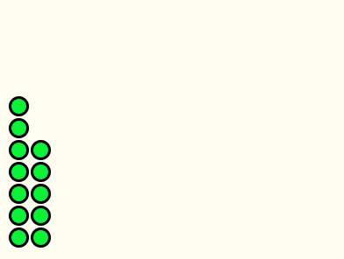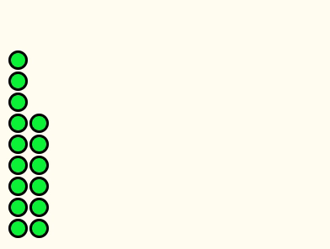
Two examples of type C.

Type D
Episodes start with n + a rows of n and b rows of a – b. They rearrange themselves through row moves into n + a – b rows of n + b, illustrating the factoring of n² + an b(a–b) = (n + a – b)(n + b) .
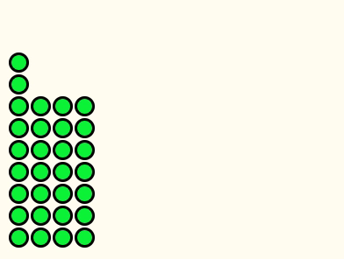
Example of type D

Pebble Arithmetic Sequences
This permits any array of pebbles, and either row by row sliding or sliding all the rows one after another. To setup an array, click & hold the mouse button and type in a sequence of numbers. Typing a single number results in a column of that height.
Example of Sequence of Number of Row Slides
The applet keeps a record of the number of row-slides until the next rectangle is formed. You can also use All Rows mode which keeps going until all the pebbles are in one row, and Film mode which runs a sequence of five episodes, each with one more pebble in the first column.
The mathematical challenge is to relate the move sequence to the array, and to characterise which move-sequences correspond to valid arrays.

Double Pebble Arithmetic
This applet enables both row and column slides to be made. When an a slide be undone by reversing the movement?
Another possible challenge is to predict the smallest number of moves that will convert a given array, such as the initial triangular array, into a rectangle.
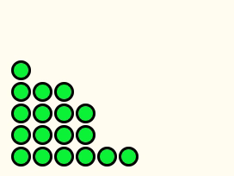
Example of moving both rows and columns

Triangular Pebble Arithmetic
This applet uses completed triangles as the pausing place rather than rectangles as in the other applets. The mathematics behind predicting the move-sequence is rather complicated! However there are less challenging tasks associated with triangular arrays, such as predicting for a given number of pebbles which triangles will be complete and the sequence of row moves required to get to them. Data provided includes the sequence of the number of pebble moves and the sequence of the number of row moves between filled triangles.
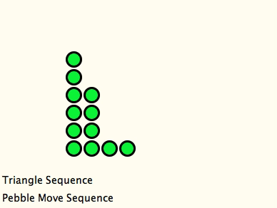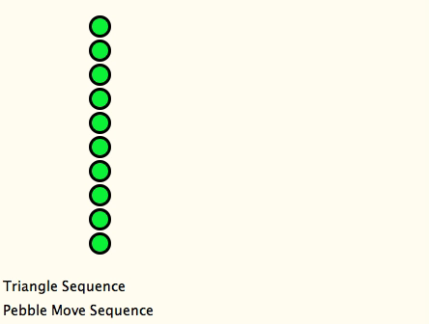
Two examples of triangular pausing points
What is being recorded by the triangle sequence and by the pebble move sequence?
Could they be used to reconstruct the film?

References
Bloor, D. (1976) Knowledge and Social Imagery, Chicago: University of Chicago Press.
Dienes, Z. (1960). Building up Mathematics. London, UK: Hutchinson Educational.
Frege, G. (1884/1950) (J. Austin, Trans.). The Foundations of Arithmetic. Oxford: Blackwell.
Hamilton, E. & Cairns, H. (Eds.) (1961). Plato: the collected dialogues including the letters. Bollingen Series LXXI. Princeton: Princeton University Press.
Mill, J. (1843). A System of Logic: ratiocinative and inductive, being a connected view of the principles of evidence, and the methods of scientific investigation. London: Parker.
Tahta, D. (1981) Some Thoughts Arising from the New Nicolet Films, Mathematics Teaching, 94, p25–29. Reprinted in Beeney, R. Jarvis, M. Tahta, D. Warwick, J. and White, D. (1982) Geometric Images, Leapfrogs, Association of Teachers of Mathematics, Derby, p117–118.

