Distance-Phase diagrams

A point P moves across a two-dimensional map along various paths.
At any moment in time, it is a distance x from point A and a distance y from point B.
These distances are marked on a graph as the point (x,y)

Map  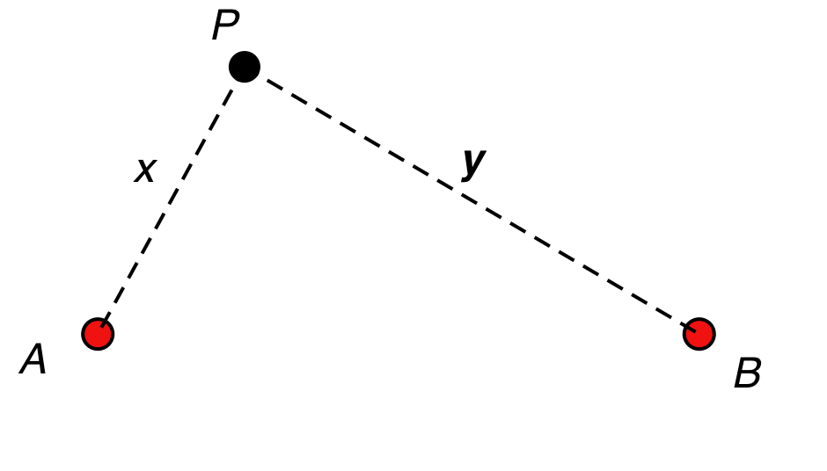 | Cartesian (x,y) graph.  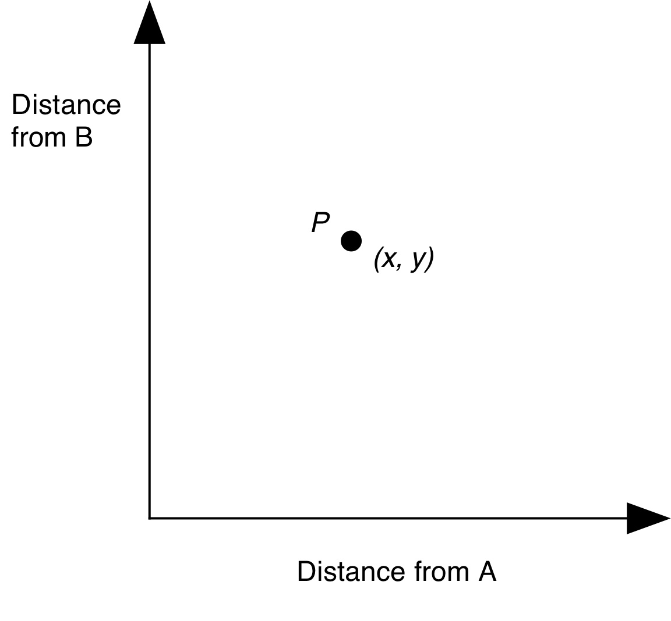

- Suppose P moves along a straight line on the map.
What will its graph look like?
Try to justify all your conjectures.
Try this for various straight lines until you have exhausted the possibilities.
- Suppose P moves across the graph along a straight line.
What could it be doing on the map?
Try to justify all your conjectures.
Try this for various straight lines until you have exhausted the possibilities.
- Now suppose P moves in a circle ……
- What about when xy = constant?
- ..and for masochists … you may like to try to prove your conjectures algebraically.

